Lisbon, April 26 to 28, 2024

INSTRUCTIONS FOR ABSTRACTS SUBMISSION TO THE FEE ECOCAMPUS CONFERENCE 2024

First Author1*, Second Author2 and Third Author2
1: R&D Unit or Department of the First A. Author Institution, Address
e-mail: FirstAuthor@email.pt

2: R&D Unit or Department of the Second B. Author and Third C. Author Institution, Address
e-mail: SecondAuthor @email.pt; ThirdAutor @email.pt

Keywords: Instructions, Conference, Ecocampus, IPL, ABAAE, FEE (max. of six keyword)

Abstract

This document presents the instructions for abstracts submission to the FEE EcoCampus Conference 2024 that will take place in Lisbon on April 26-28, 2024, which must be written in English and contain: the title of the work, the names, affiliations and authors' contacts, keywords and abstract. The abstract should be one to two pages (between 200 and 500 words). It must be written in Arial, size 12. Acknowledge and References, if used, should be presented in Arial, size 10. Entries must be submitted in .doc, .docx format until March 15th 2024. Figures, tables, citations, and references are optional.
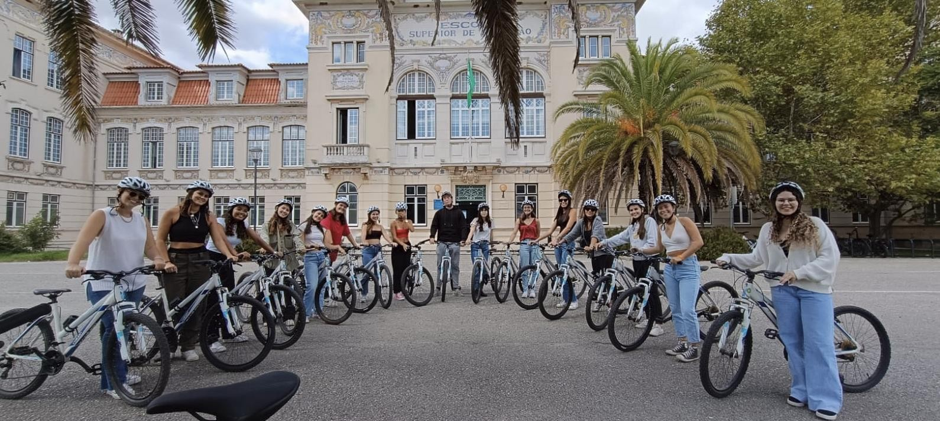
Figure 1 – Students from the Lisbon School of Education engaged in a soft mobility activity (optional).

The official language is English. Proposals can be accepted either as oral presentations or poster presentations. Exceptionally, abstracts for the organization of workshops may be accepted. In this event, the author of the oral communication has the possibility to make the presentation of his work in parallel sessions, with time

First A. Author, Second B. Author and Third C. Author

and space in the program, for a brief presentation of the posters. A person can be a co-author of several articles as long as each work is presented by a different co-author. Each valid registration authorizes the author to submit up to 2 papers in the conference. Contributions received after the deadline or without a valid registration, may not be included in the book of abstracts.

Acknowledgments - should be presented in Arial, size 10 References – should be presented in Arial font size 10 (APA style)

CONFERENCE TOPICS

From Eco-Schools to EcoCampus
- EcoCampus practices and its contribution to SDGs goals.
- The role of youth leadership in Education for Sustainable Development.
- Outdoor and Place-based Learning in Environmental Education.

Training e Curricula
- Challenges and pedagogical approaches to content integration in teacher training in Education for Sustainable Development.
- Good practices in integrating of environmental sustainability contents in Technical and Vocational Education and Training (TVET).
- The role of internationalization and partnerships in environmental sustainability in higher education.

Innovation and Development
- Communication trends and techniques in sustainability programs in higher education.
- Benchmarking and networking - learning between peers, taking advantage of experiences that promote sustainability and environmental management.
- Challenges, technologies and approaches to greening higher education infrastructure and facilities.

EcoCampus and the Community
- Education for Environmental Citizenship - The role of the EcoCampus outside of the school walls.
- The role of EcoCampus in combating the Triple Planetary Crisis: Climate Change, Pollution and Loss of Biodiversity.
- Artificial Intelligence and Smart Technologies: an opportunity to make the campus more sustainable.

